Outlines for Mitosis Flip Books

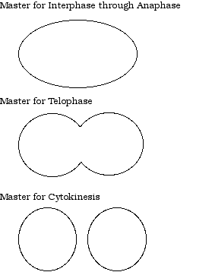

T. (Trimpe) Tomm, 1999

